|  |  |
| --- | --- |
| **STUDENT ASSESSMENT FORM** |  |

***By submitting this assignment I confirm that I have not sourced or used any information from any online ‘essay’ provider nor any other third party not acknowledged in my assignment.***

|  |  |  |  |  |  |  |  |  |  |  |  |  |  |  |  |  |  |  |  |  |  |  |  |  |  |  |  |
| --- | --- | --- | --- | --- | --- | --- | --- | --- | --- | --- | --- | --- | --- | --- | --- | --- | --- | --- | --- | --- | --- | --- | --- | --- | --- | --- | --- |
|  | | | | | | | | | | | | | | | | | | | | | | | | | | | |
| Student Registration Numbers: | | | | | | | 3014304 | | | | | | | | | Mode Code: | | | | | MANP001  Assignment 2 | | | | | |  |
|  | | | | | | | | | | | | | | | | | | | | | | | | | | | |
| Tutor’s Name: | | | | | | | Tom Kane | | | | | | | | | | | | | | | | | | | |  |
|  | |  | | |  | | | |  | |  | | |  | | | |  | |  | | |  | |  | | |
|  |  | |  |  | |  | |  | |  | |  | | |  | |  | |  | |  |  | |  | |  | |
|  | | | | | | | | | | | | | | | **Grade Descriptors** | | | | | | | | | | | | |
|  |  | |  |  | |  | |  | |  | |  | | |  | | | | | | | | | | | | |
| **Criteria (that meets the module learning outcomes)** | | | | | | | | | | | | | | | 0-29% | | 30-39% | | 40-49% | | 50-59% | 60-69% | | 70-79% | | 80-100% | |
|  |  | |  |  | |  | |  | |  | |  | | |  | |  | |  | |  |  | |  | |  | |
| Adherence to presentation brief: adherence to the format (summary, contents page, simulation of demand, description of model, validation of model, analyses of scenarios and management options, other suggestions, recommendations) | | | | | | | | | | | | | | |  | |  | |  | |  |  | |  | |  | |
| A simul8 simulation of how the factory could meet a production target of 15,000 bikes a year | | | | | | | | | | | | | | |  | |  | |  | |  |  | |  | |  | |
| Description of the simul8 model, highlighting the key features (this must include material derived the analyses of assignments 1 and 2 but emphasising the enhancements) | | | | | | | | | | | | | | |  | |  | |  | |  |  | |  | |  | |
| Analysis of what this will mean for the business, with reference to the key objectives. | | | | | | | | | | | | | | |  | |  | |  | |  |  | |  | |  | |
| Recommendations: interpreting the results of the analysis and the consequent suggestions for management action | | | | | | | | | | | | | | |  | |  | |  | |  |  | |  | |  | |
| Report impact: presentation format, logical coherence and writing/graphics quality | | | | | | | | | | | | | | |  | |  | |  | |  |  | |  | |  | |
|  |  | |  |  | |  | |  | |  | |  | | |  | |  | |  | |  |  | |  | |  | |
| **General Comments** | | | | | | | | | | | | | | | | | | | | | | | | | | | |
|  | | | | | | | | | | | | | | | | | | | | | | | | | | | |
|  | | | | | | | | | | | | | | | | | | | | | | | | | | | |
| See detailed comments overleaf. | | | | | | | | | | | | | | | | | | | | | | | | | | | |
| Markers Signature | | | | | | | | | | | | |  | | | | | | | | | | | | | | |
|  | | | | | | | | | | | | |  | | | | | | | | | | | | | | |

|  |  |
| --- | --- |
| Mark |  |
|  |  |
| Penalty for Late Submission |  |
|  |  |
| **FINAL MARK** |  |

Students are required to make assessed coursework available for the External Examiner and the Centre is required to store past student assessments for teaching quality assessment purposes. Marked assignments should therefore be returned to the Divisional Support Office by the end of semester.

Work which is submitted for assessment must be your own work. All students should note that the University has a formal policy on plagiarism which can be found at <http://www.quality.stir.ac.uk/ac-policy/assessment.php>

|  |  |
| --- | --- |
| **STUDENT FEEDBACK** |  |

|  |  |  |
| --- | --- | --- |
| Criterion | **%** | **Comment** |
| Adherence to presentation brief: adherence to the format (summary, contents page, analysis of demand, description of model, validation of model, analyses of scenarios and management options, other suggestions, recommendations) | 15 |  |
| A simul8 simulation showing how the factory could meet a production target of 15,000 bikes a year | 20 |  |
| Description of the simul8 model, highlighting the key features (this must include material derived the analyses of assignments 1 and 2 but emphasising the enhancements) | 20 |  |
| Analysis of what this will mean for the business, with reference to the key objectives. | 20 |  |
| Recommendations: interpreting the results of the analysis and the consequent suggestions for management action | 15 |  |
| Report impact: presentation format, logical coherence and writing/graphics quality | 10 |  |



* **Name: Rohit Pravin Sapkal**
* **Course: Data Science For Business**
* **Subject: Business Analytics**
* **Roll Number: 3014304**

Table of Contents

* **List of figures**
* **Introduction**
* **Objective**
* **Methods**
* **Discussion**
* **Result**
* **Recommendation**
* **Reference**
* **Appendices**

**List of Figures**

Figure 1: Basic model

Figure 2: Start Point

Figure 3: Model 1 or 2

Figure 4: Build Frame

Figure 5: Installation of electric components

Figure 6: Installation of Mechanical Components

Figure 7: Final Quality Check

Figure 8: Dispatch

Figure 9: Queue

Figure 10: Start Point with Result

Figure 11: Model 1 or 2 with Result

Figure 12: Build Frame with Result

Figure 13: Installation of electric components with Result

Figure 14: Installation of mechanical Components with Result

Figure 15: Final Quality Check with Result

Figure 16: Dispatch with Result

Figure 17: Recommendation

**Introduction:**

Braeheart eBikes is a bicycle manufacturing firm that began in 2014 and produces around 5500 cycles per year. However, in the 2020-2019 fiscal years, bicycle orders increased rapidly. So we analyze the data supplied by the organization and present them with an acceptable solution for quality. Now, using simulation models, we assist them in achieving smooth production and growth. Because there are too many models, customers are confused about which one is the right bicycle for them. This problem will be raised by the Marketing Manager, and we will also conduct some interviews to gain a better understanding of the quality problem. We discovered that each source has its own point of view on the bicycle quality problem, such as the purchasing manager, who discovers that there are more basic problems in mechanical components. The production manager wants to know whether there are many methods to improve the quality of production at the old workstation. As an example, there are several flaws that every source will uncover, which we will resolve utilizing our analytical talents. Using previous statistical data, the production manager discovered that the supplier had pre-painted the basic components with the Braeheart logos, and the marketing manager had also attempted to address consumer confusion, such as the fact that there are too many models, which causes customer confusion.

**Objective:**

We will utilize the Simu8 model to determine what we need to do to manufacture 15000 bicycles every year, and if required, we will work an extra shift to achieve our objective and present an accurate solution to the CEO. We are now running this bicycle factory for a week, while the other scenarios stay the same, such as 6 minutes for quality control and 50 minutes for mechanical components. Using all of this information, we found a solution and compared it to the client's requirements. For this, we only used model 1 and model 2 to make 15000 bicycles. We also put certain resources in place to help the factory's output improve.

**Methods:**

Firstly developed the basic model which will base on the following process.

* **Model 1 or 2 (Activity 1):**
* **Build frame**
* **Install electric components**
* **Install mechanical components**
* **Final quality check**
* **dispatch**

Using above procedure the following model is based on it.

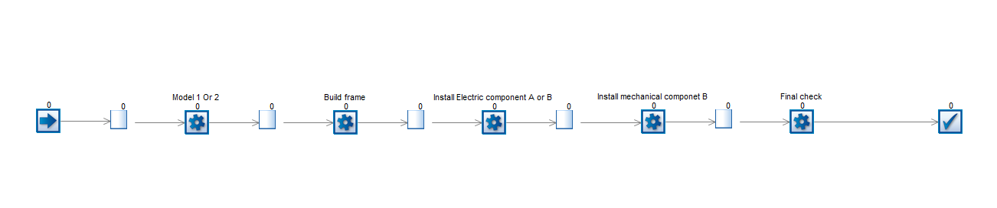

Fig1 model

* **Start point:**

This is where we begin our order-taking process, which means that orders will be entered in it. In our case, which will be 15000 bicycles per year? Furthermore, our factory runs seven days a week for eight hours, so we put values like 365*8/15000, which means 2920 hours per year so that new orders will be received every 0.1946 hours with fixed distribution.

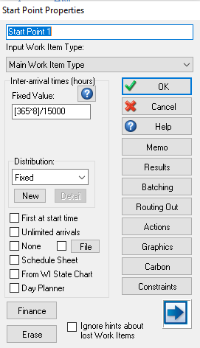

Fig 2 Start Point

* **Model 1 or 2 (Activity 1):**

This activity where we get the order for model 1 and model 2 it also known as work station where specific work will be done by the machines or servers in this model it only follow the one route with fixed distribution. This activity gives us detailed information about times.

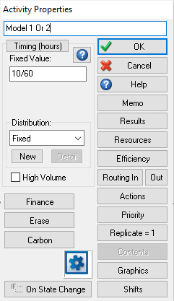

Fig 3 Models

* **Build frame:**

This is also the operation where frame get build this is also known as activity this work station comes after the model station this work station build the frame which is compatible for the models with fixed distribution.

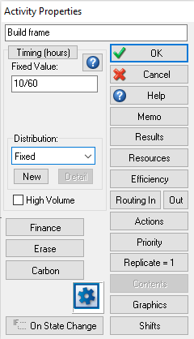

Fig 4 build Frame

* **Install electric components:**

In this work station where electric components get installed in the bicycles with fixed distribution this operation will takes place after building the frames.

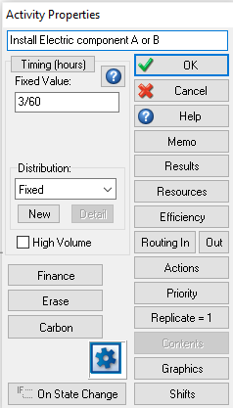

Fig 5 Electric part Installation

* **Install mechanical components:**

This activity put the mechanical components in the bicycles, which took nearly 50 minutes with fixed distribution. This is the second last procedure for bicycles manufacturing, and the bicycles are virtually ready for the final quality check following this workstation.

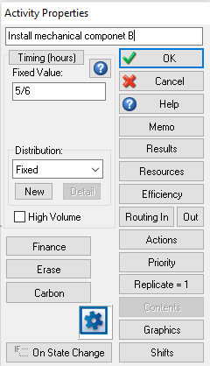

Fig 6 Mechanical Part Installation

* **Final quality check:**

Bicycles will be examined at this workstation for specific factors such as quality, and this is the last workstation for the bicycle production process; also, quality checks will take 6 minutes with fixed distribution.

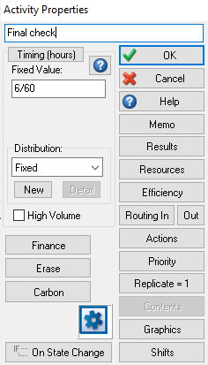

Fig 7 Quality Check

* **dispatch:**

This is the point at which the bicycles depart the production process, indicating that they are ready for sale. Here we learn how many cycles are ready for delivery, and we can use this information to recommend modifications to boost the factory's productivity.

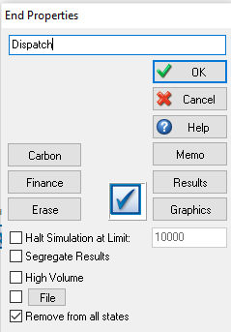

Fig 8 Dispatch

**Discussion:**

Braeheart eBikes is the bicycle manufacturing company in covid-19 the order for the bicycles dramatically increased. They have some specific processes for manufacturing bicycles, such as installing mechanical and electrical parts, building frames, quality checking, and so on, but they want to increase production of model 1 and model 2. Before implementing, each factory should go through a dummy model, also known as a simulation model (simul8) we may learn about the whole plants or the analytical basis of bicycle manufacture, as well as the effect or how many employees are required for bicycle production. It assists us in resolving a variety of challenges, allowing factory owners to save a significant amount of money, all of which occurs prior to the plant's implementation.

To begin, we obtain the number of orders; this information is supplied by the clients; in this case, we have 15000 orders every year; most significantly, our factory operates seven days a week for eight hours. All of this has previously been covered in the preceding section. I used these numbers as the model's starting point with the fixed distribution. Following that, the queue plays a crucial function in storing data or serving as a waiting interval before the following operation. Second, we have model 1 or 2 activity where we get orders for model 1 or 2. Following this, our process has one more waiting time, the frame is built at the build frame workstation for the models that we received from the previous process, and we repeat the process. I added a queue before the next process to help focus on completing the first bicycles before moving on to the second. Later on, we have an installation of an electric component workstation where the machine installed the electric motor into the models. After this motor is installed, we have to install mechanical components at the installed mechanical components workstation. It will take 50 minutes to complete. Finally, bicycles are ready for the quality check, which is the final phase in this production process and also takes 6 minutes for quality check. Finally, bicycles are ready for distribution, which we call the dispatch process in this simul8 model. We don't require a waiting interval between Dispatch and Quality Check since bicycles did not need to wait after the quality check workstation. Initially we take the every queue with none waiting time.

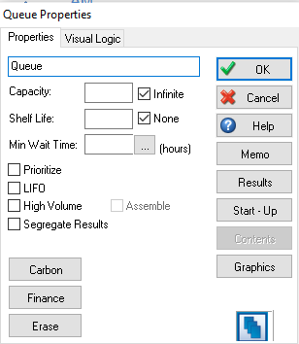

Fig 9 Queue

**Results:**



* **Start points:**

The 10684 models are inserted into start points, implying that we got around 11000 orders using 365*8/15000. All of these orders are sent to the next workstation.

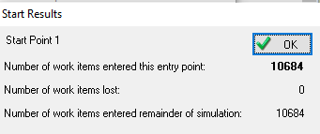

Fig 10

* **Model 1 or 2:**

On an average it takes 0.86 hr. and maximum it takes 1hr for the completion it work 85.60% which still give us a 100% production Moreover, Queue which is after model 1 or model 2 hold 5 models in it but that should be neglected. There are nothing in queue it pass all the model without waiting in the queue.

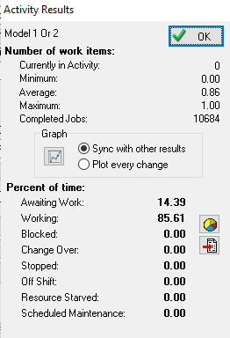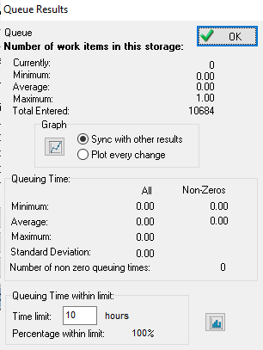

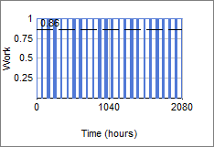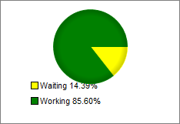 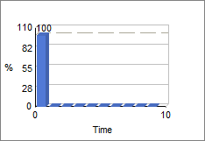

Fig 11

* **Build Frame:**

This workstation takes 0.85 hr. to build the frame and it completed 10678 models which means here they get 6 less jobs in percentage it worked 85.56% jobs. In this queue 11 models are in waiting period for the next operation of manufacturing bicycles.

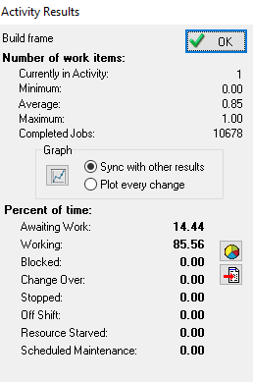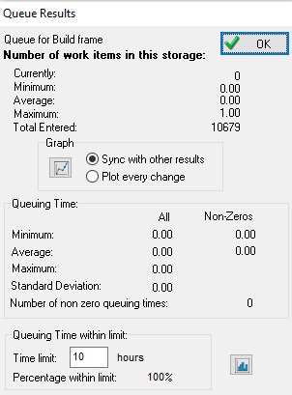

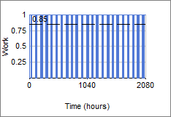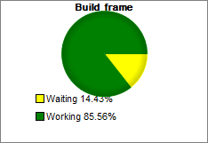

Fig 12

* **Electric components A or B:**

This activity takes 0.26 hr. to complete the job it complete 10672 jobs this workstation worked 25.65% and 74.34% is in waiting.

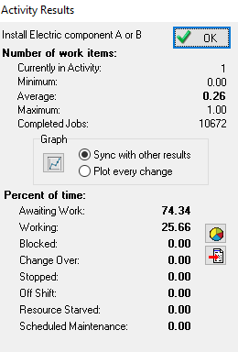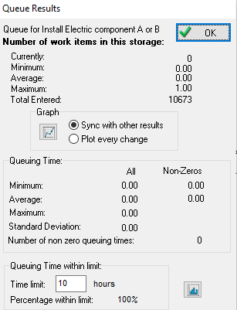

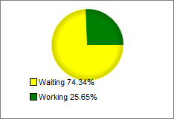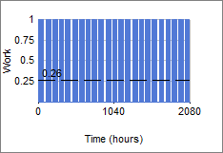

Fig 13

* **Mechanical Components:**

This workstation takes 1 hr. to complete the job so that we get high number of waiting models In the queue which is almost 8175 moreover the job get entered is 10667 in the waiting station.

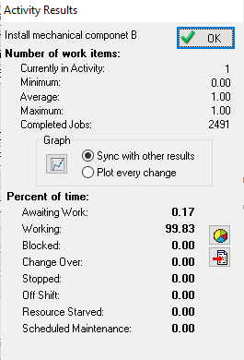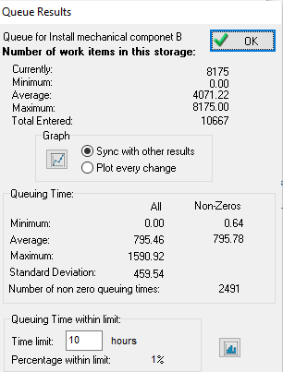

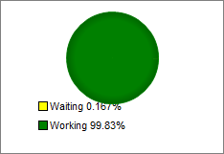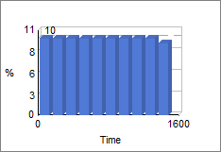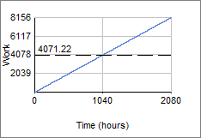

Fig 14

* **Quality Check:**

Quality check complete almost 2490 jobs Moreover, working is 11.97% and waiting 88.02% time. But the queue holds the same they pass to the quality check workstation.

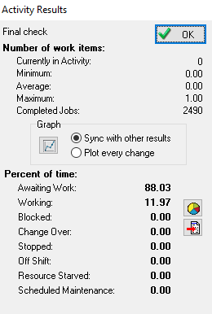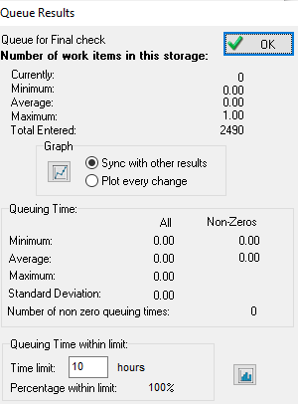

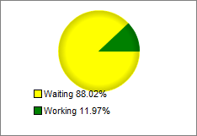

Fig 15

* **Dispatch:**

2488 bicycles get ready for the dispatch after quality check operation moreover it takes time in the system 801.32 hr. in average and standers deviation is 458.80.

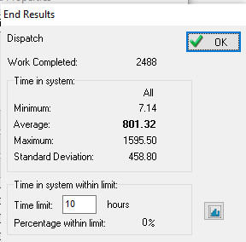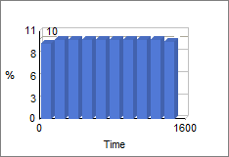

Fig 16

After Overviewing all the above results it is not possible to get desired output in one year for getting desired result we need to make some change s in the input or may be need to change the quantities.

**Recommendation:**



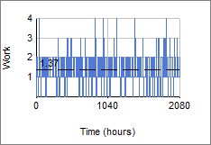

Fig 17

If we need to generate 15000 orders per year so that we need to make some changes in the model such as we need to put 365*8/21100 value at the starting point which gives us information about we have 2920 hr. in the years moreover we get the new order at every 0.138 hr. Simultaneously we need to reduce the time for every activity which is 0.7/60 hr. which shows us that each activity takes only 0.7/60 hr. to complete the job moreover most importantly we need to reduce the mechanical installation timing to increase the productivity of that workstation because of this there are no more waiting jobs in the queue although we put the same time for the final check which is 6 min still we get the desired result. Using all changes we achieve the target of 15000 orders in the year.

**References:**

**Simul8. (n.d.). Simul8. https://www.simul8.com/support/help/doku.php?id=tutorials**

**Appendices:**

**For the Practice purpose I create the new model using some different thinking I will attach this model as well.**

